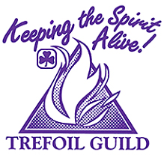Newfoundland Labrador
100 Years and COUNTING!
1918…

Provincial Trefoil Guild Gathering
Lion Max Simms Memorial Camp

Name: _________________________________ IMIS #: _________

Mailing Address: ______________________________________________

Phone #: _____________________ Email: ____________________

Member of _______________________________Trefoil Guild

Number of years in Guiding ________

Note: Personal Health Form (H2) is to be carried on person at all times. One will be sent to you with your kit list.

PLEASE INDICATE THE FOLLOWING

Allergies: Yes No

Dietary Restrictions Yes No

Mobility Restrictions Yes No
If yes to any above, please specify

Are you sleeping in? Building Tent (if tenting, please provide own tent)

Are you willing to take a top bunk if no bottom is available? Yes No

Is there a person (s) you would like to share your room with ________________________

Registration Fee: FULL WEEKEND $150.00 SATURDAY ONLY: $60.00

Please make cheque(s) payable to Girl Guides of Canada- NL Provincial Trefoil Gathering 2018

Return completed forms and down payment ($25.00) by March 11, 2018 to:

Dianne Batten
17 Lexington Pl
Conception Bay South NL A1X 6A2

(Phone: 709-834-8181 or email: dabatten51@gmail.com)

